ACTIVITY – 08

Name: T. Jithendra

Register Number: 192111521

Course Code: DSA0163

Course Name: Object Oriented

Programming with C++

Static Memory Function:

#include<iostream>

using namespace std;

class A{

public:

int a;

static int b;

void increment(){

a = a + 10;

b = b + 10;

cout <<a << b;

}

};

int A::b = 0;

int main(){

A A1,A2;

A1.a=10;

A2.a=20;

A1.increment();

A2.increment();

}

Output:

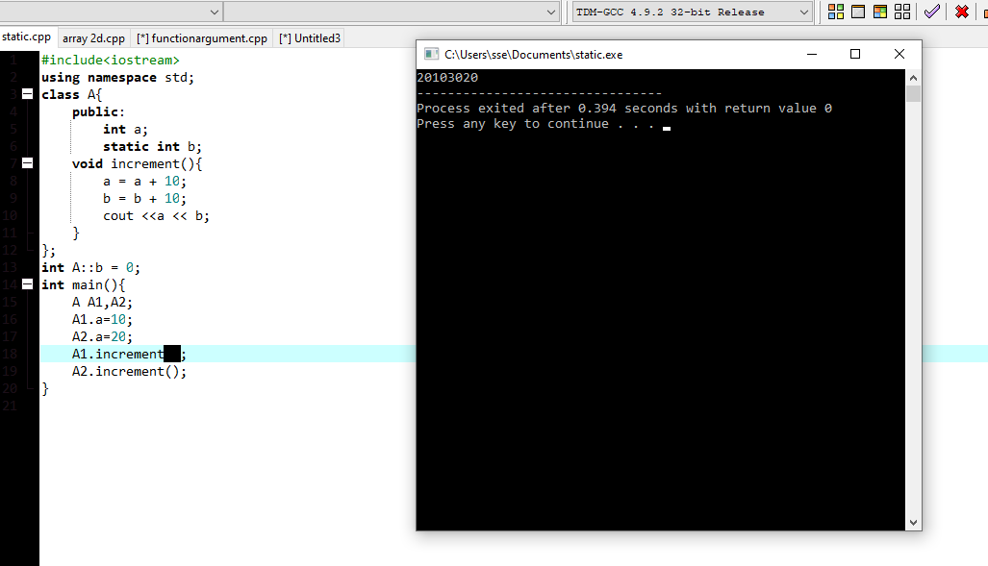

Dynamic Memory Allocation of 2D Arrays:

#include<iostream>

using namespace std;

int main(){

int rows = 3;

int cols = 4;

int \*\*a = new int \*[rows];

for (int i=0;i<rows;i++){

a[i] = new int[cols];

}

for (int i=0;i<rows;i++){

for (int j=0;j<cols;j++){

cin >> a[i][j];

}

}

for (int i=0;i<rows;i++){

for (int j=0;j<cols;j++){

cout << a[i][j];

}

}

return 0;

}

Output:

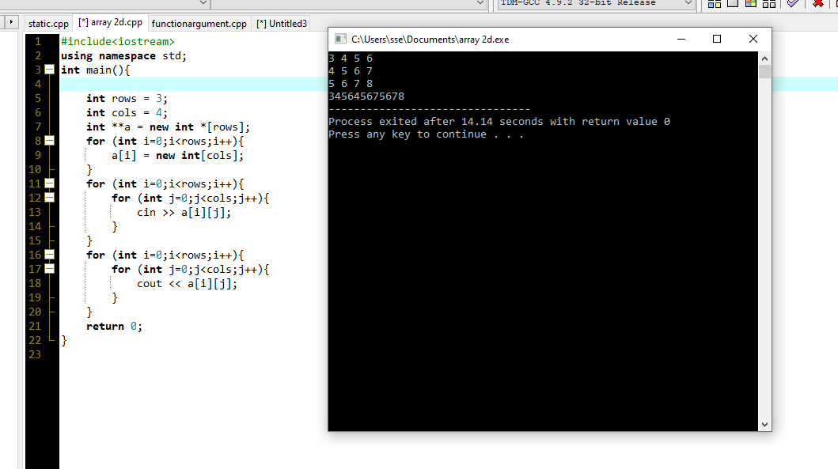

Function with Default Argument:

#include<iostream>

using namespace std;

class a{

public:

int sum(int a,int b,int c=10,int d=20){

return (a + b + c + d);

}

};

int main(){

a a1;

cout << a1.sum(10,20,100,200);

cout << a1.sum(10,20,100);

cout << a1.sum(10,20);

}

Output:

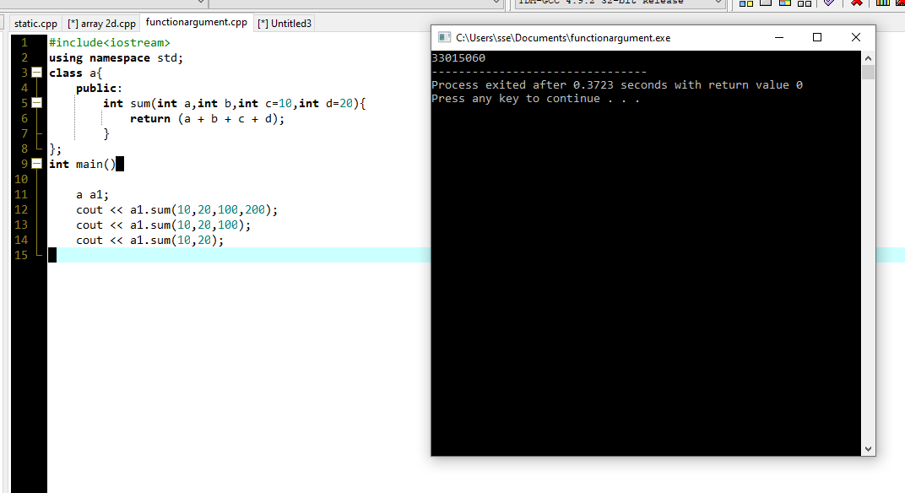

Virtual Based Class:

#include <iostream>

using namespace std;

class A

{

public:

int x;

void read()

{

cout<<"Enter the number x \n";

cin>>x;

}

void display()

{

cout<<"X = "<<x<<"\n";

}

};

class B : virtual public A

{

public:

int y;

void read1()

{

cout<<"Enter the number y \n";

cin>>y;

}

void display1()

{

cout<<"Y = "<<y<<"\n";

}

};

class C : virtual public A

{

public:

int z;

void read2()

{

cout<<"Enter the number z \n";

cin>>z;

}

void display2()

{

cout<<"Z = "<<z<<"\n";

}

};

class D : public B , public C

{

public:

int d;

void read3()

{

cout<<"Enter the final number \n";

cin>>d;

}

void display3()

{

cout<<"D = "<<d<<"\n";

cout<<" X + Y + Z + D = "<<x+y+z+d<<"\n";

}

};

int main()

{

D D1;

D1.read();

D1.read1();

D1.read2();

D1.read3();

D1.display();

D1.display1();

D1.display2();

D1.display3();

}

Output:

